Name: yousef tawfeek

B.N: 141115

Topic: football

Github-link: <https://github.com/Yousef-nazeer/Web_project>

Github-page: <https://yousef-nazeer.github.io/Web_project/index.html>

Application Brief: I made a Web page about football , it consist of home page that talking about football. The second page is "Premier league" it is taking about the premier league table. The third page "Legends", it is talking about legends of football. The fourth page is "Games" which talking about football games . The last one is registration form.

Home



Premier League

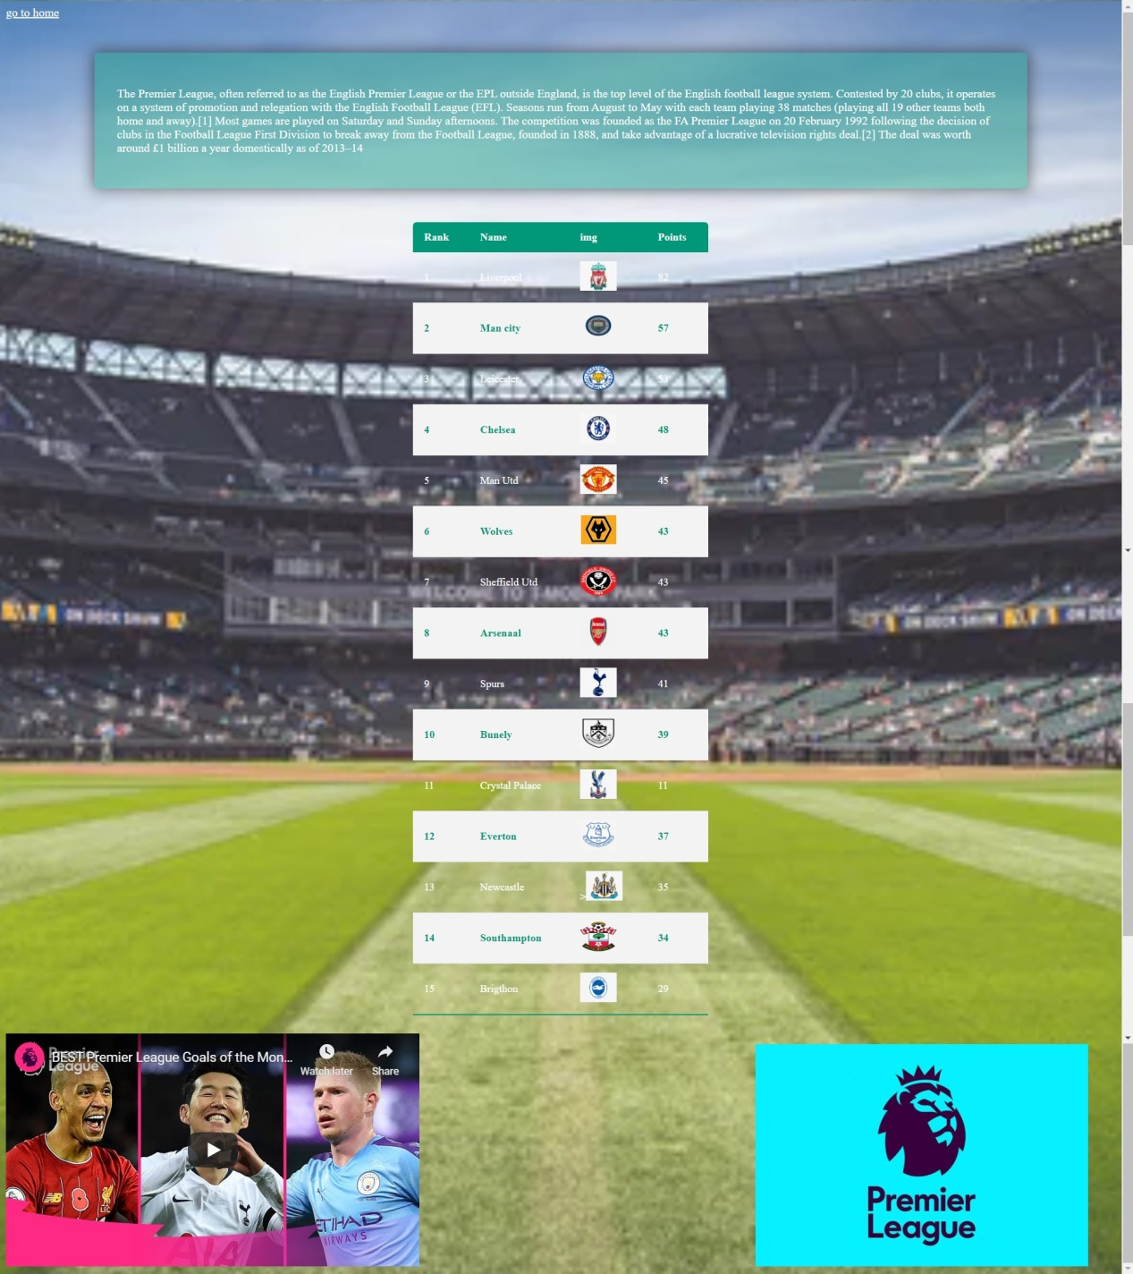

Legends

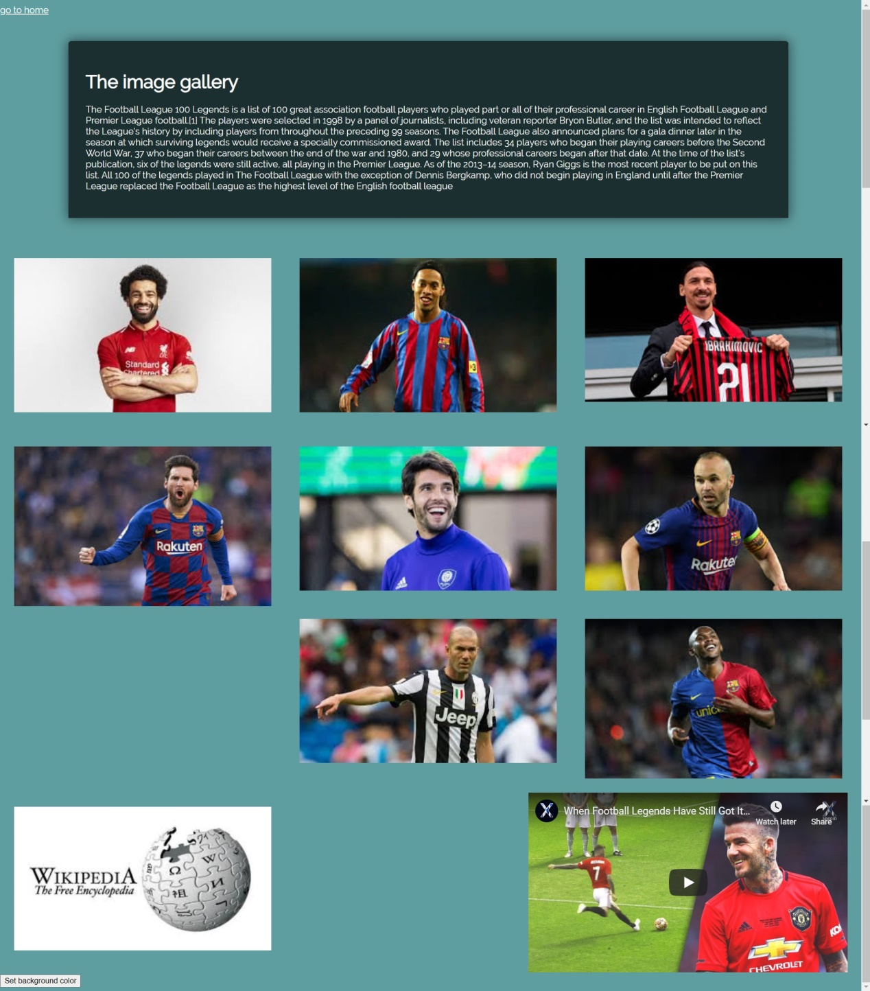

Games



Registration

